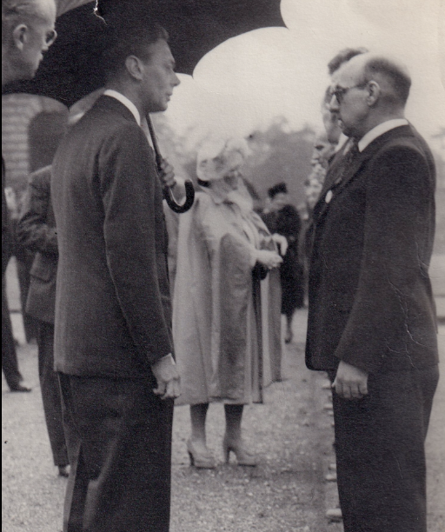


‘Guide me in your truth and teach me,
for you are God my Saviour and my hope is in you all day long.’

Hello,
Wow, we are in the last week of the half-term already. How time flies! We enjoyed our trip to Sheffield Cathedral and the children’s behaviour was exceptional.
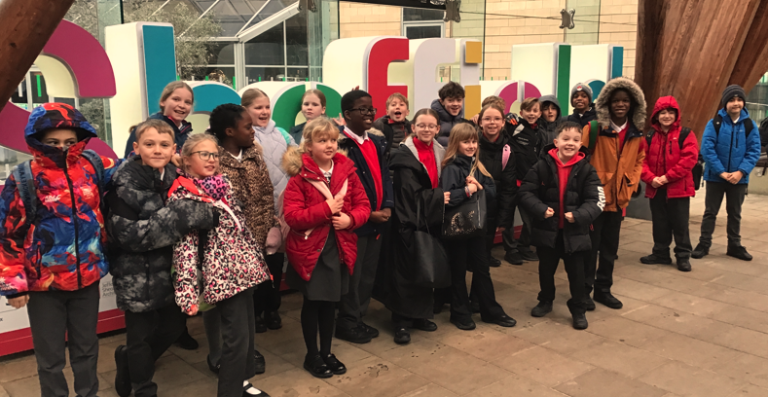

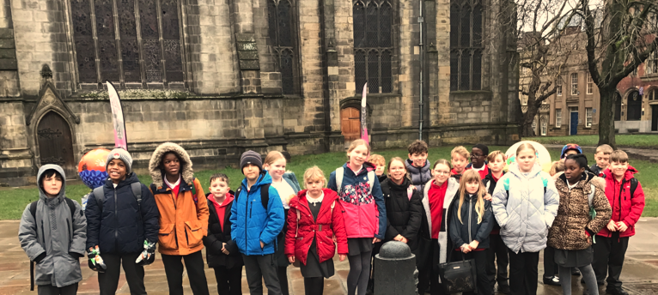

This week we are completing our learning around A Midsummer Night’s Dream. We have really loved the story and the songs. This week, we will be completing our diary entries as one of the characters and sharing our thoughts about the story in our ‘Love to Read’ book review.

In Maths, we will be learning how to calculate decimals and percentages.

Coal Mining is our History topic and in RE will we are thinking about Creation and Fall. This week, we will be thinking about the dangers of Coal Mining. In PE, we have a Basketball and Circuits focus, Science is Forces and in PSHE, we are learning how to manage anger.

Reminders for the Spring term-
PE will be Monday and Friday.
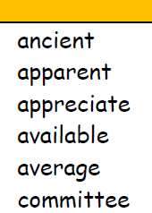
Home learning will be set on a Thursday and handed in on the following Monday please.
This week is My Maths- times tables and a revisit
of formal calculations for addition and subtraction.

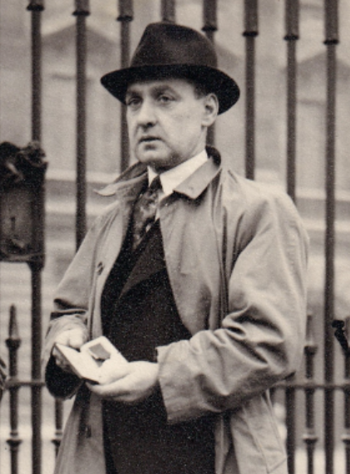
Don’t forget to see what we are up to by following us on Twitter/X and our school website
Take care,
This is my grandad. He was awarded the George Cross for his bravery when rescuing men from a pit explosion.
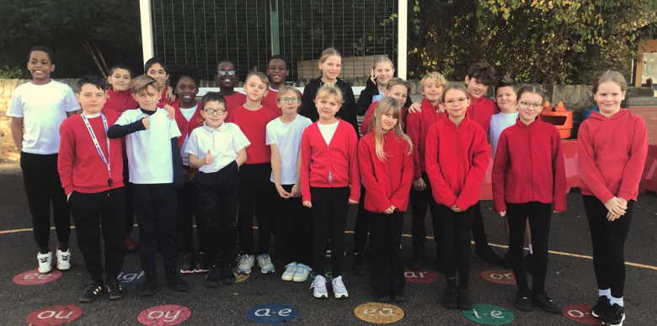
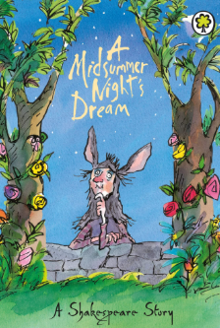
Lorna Johnston

