



Guide me in your truth and teach me,
for you are God my Saviour and my hope is in you all day long.
11.9.23
Hello,

We are all prepared for the Capulet Ball and should be well disguised in our homemade masks.

Here are a few things happening this week.
In English we will be using the text ‘Romeo and Juliet’ as a stimulus for our learning.
Main activities for English are- To be able to use inverted commas to show what characters are saying, to be able to use a colon to introduce a list and to be able to pick out fabulous writing skills from a diary model.
In Maths our theme is Number and Place Value. Our Maths Meetings for this half term will focus on fluency of numbers and place value.
Curriculum activities for this week include- RE-How did God use Moses to bring about freedom and Moses? History- Romans: Chronology of events from the past within and beyond living memory. Science- Light: How does light travel?
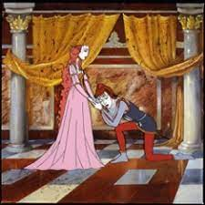
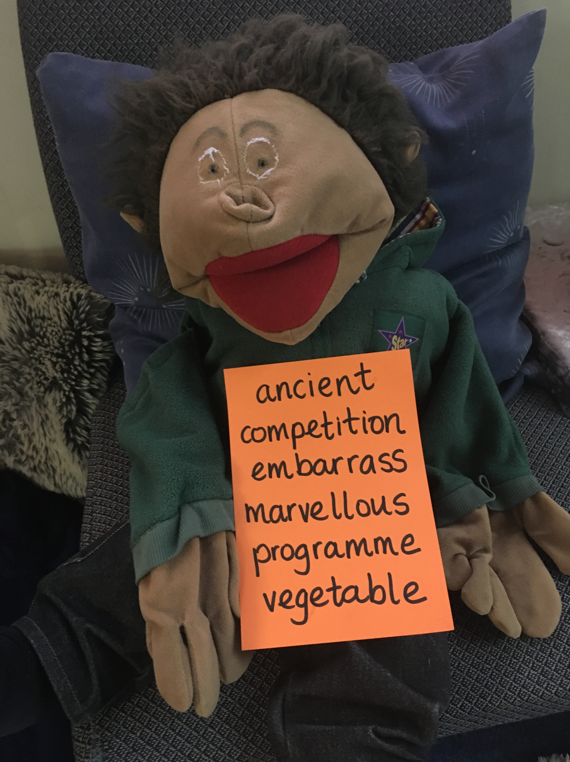
These are the spellings we are working on at the moment.

It was so lovely to see the many comments in the children’s reading diaries. It’s obvious that they have a love of reading. Thank you.
Don’t forget to see what we are up to by following us on Twitter/X and our school website.
Lorna Johnston

