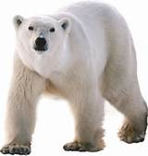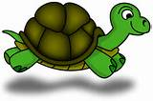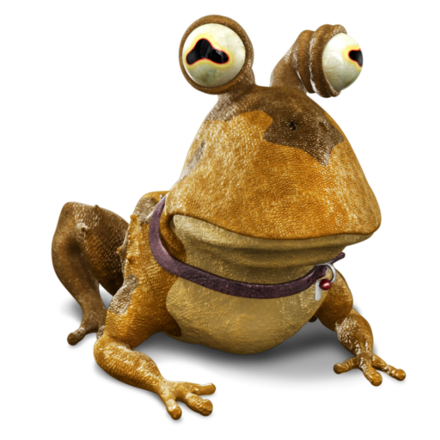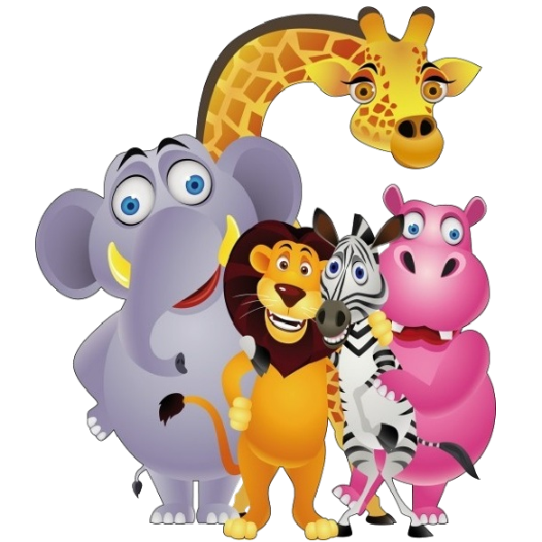

**PSHE**

**Hazard Watch** – Is it safe to drink?

**Music**

Vocal skills and composing music

**Computing**

Unit 1.7 Coding using 2Code

To understand what coding means in computing. To create unambiguous instructions like those required by a computer. To build one- and two-step instructions using the printable code cards. To introduce 2Code. To use the 2Code program to create a simple program. To use Design Mode to add and change backgrounds and characters. They will use the Properties table to change the look of the objects. To use the Properties table to change the look of the objects. To design a scene for a program. To use code blocks to make the characters move automatically when the green Play button is clicked. To add an additional character who moves when clicked. To explore the When Key and When Swiped commands (on tablets if available). To use the Stop button to make characters stop when the background is clicked. To explore a method to code interactivity between objects. To use Collision Detection to make objects perform actions. To use the sound property.

**Science**

**Animals (including humans)**

Identify and name a variety of common animals including fish and reptiles

Identify and name a variety of common animals that are carnivores, herbivores and omnivores

Describe and compare the structure of a variety of common animals (fish and reptiles)

**Year 1**

**PE**

Games

**Geography**

**How do we map our school?**

Where are places on a map? What are the key features of our school? How to create a map of our school? How do we use a map? What are the 5 Oceans?

**DT**

**DESIGN, MAKE AND EVALUATE/TECHNICAL KNOWLEDGE** - Make moving pictures

**COOKING AND NUTRITION** - grow own vegetables to cook and taste

**RE**

**Buddhism** - What do Buddhists believe?

**Enhanced provision**

**Easel** – animal pictures and paintings.

**Role play** – Jungle Explorer

**Reading corner** – animal story books, animal magazines, non-fiction books about animals, information leaflets about animals.

**Maths area** – Linked to maths learning

**Enquiry Area** – Linked to living things and habitat

**Small Word** – Jungle and arctic

**Going Wild**

**Term 3b**

**Sr**

**Maths** problem solving will have cross-curricular and topic links including global learning links

**Fractions**

* Find a half and a quarter of an object, shapes and quantity.

**Number – Place Value**

* Count forwards and backwards to 100.
* Read and write numbers to 100 and find one more and one less.
* Use objects and pictorial representations to represent numbers to 100.

**Money**

* Recognise and know the value of different coins and notes.

**English**

* Phonics – Read Write Inc.
* Stories -Meerkat Mail
* Non-Fiction – Animal Facts
* Recount – Trip to Yorkshire Wildlife Park

**Community** – as members of the community we will develop our outside space.

**Enquiry** – we will use books, pictures and other sources of information to find out about different animal groups, animals in the past and animals around the world. We will use our enquiry skills to find out more.

**Respect** – as respectful citizens we will learn to treat animals fairly and considerately. We will learn ways in which we can help animals and ways in which they help us in return. We will learn to respect and learn from ways of life in different parts of the world.