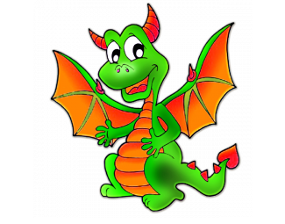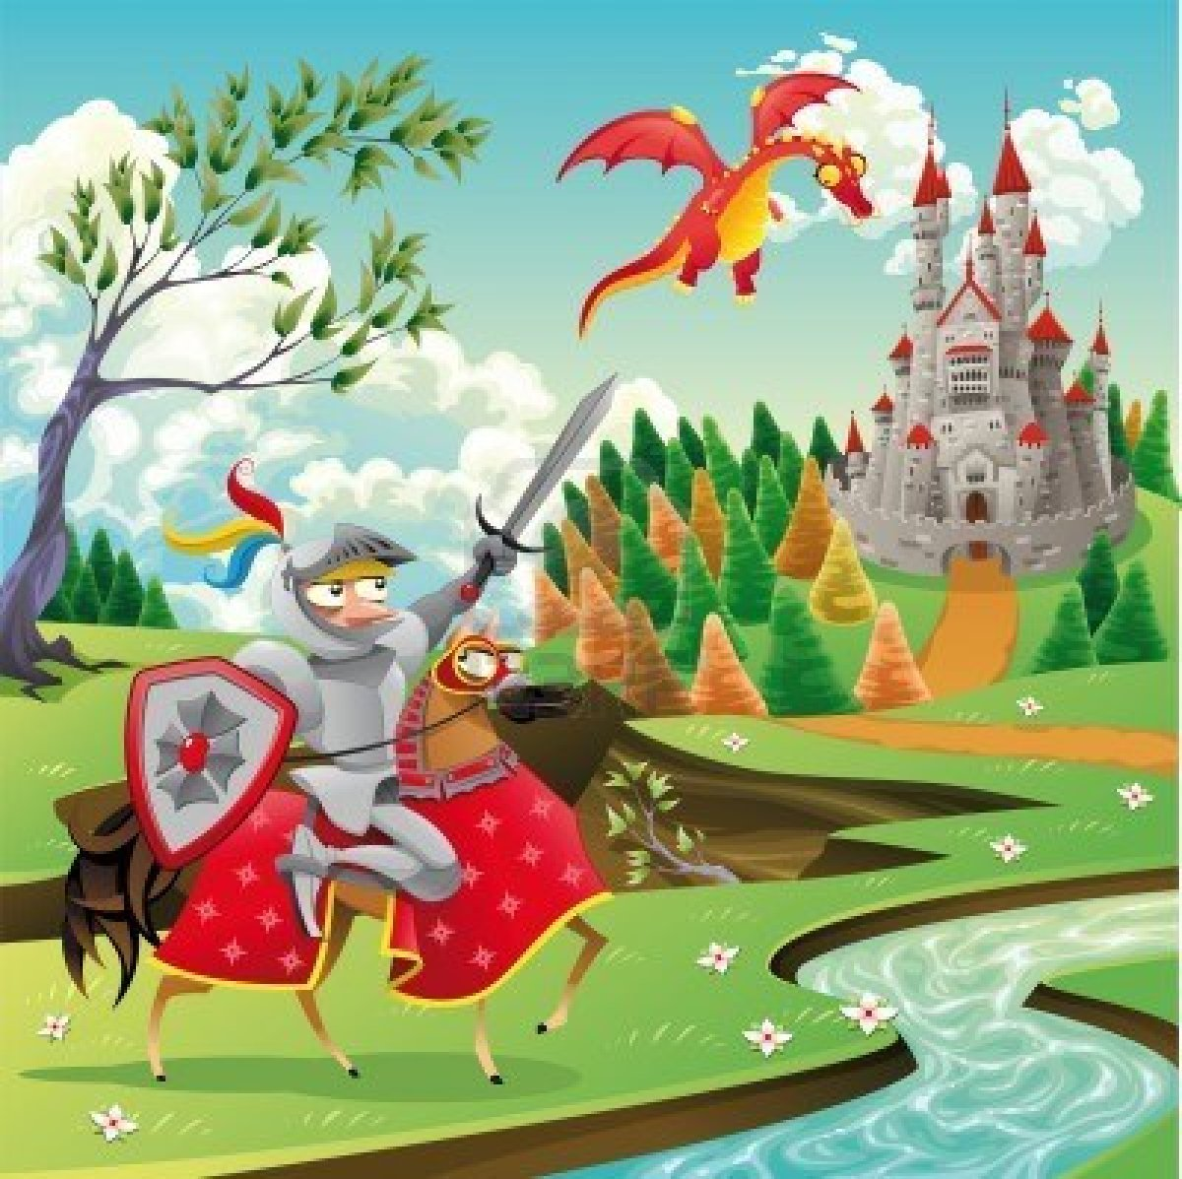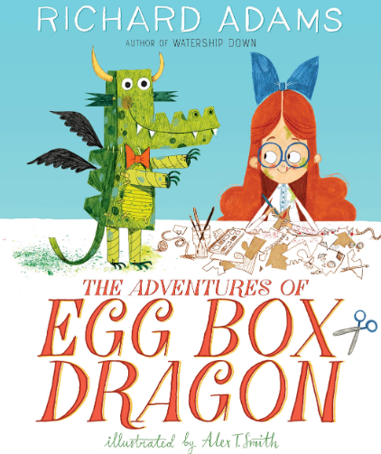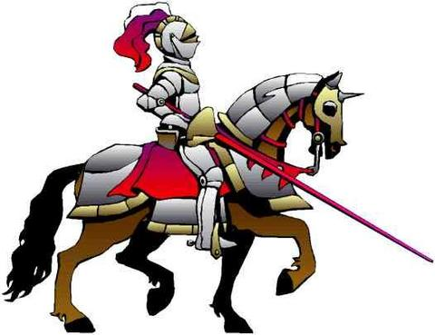

**PE**

Dance

**Music/Drama**

Loud and quiet dynamics

**English**

* Phonics – Read Write Inc.
* The Adventures of Egg Box Dragon by Richard Adam
* Instructions – How to catch a dragon
* Poetry - Poems on a theme (dragons)

**Maths**

**Number: Addition and subtraction**

* Add by counting on
* Find and make number bonds
* Subtraction crossing 10/not crossing 10
* Addition and subtraction fact families
* Comparing number sentences

**Measurement: Weight and Volume**

* Measure and record capacity and volume
* Solve practical problems

**Year 1**

**Enhanced provision**

**Creative Area** – Design and make a dragon

**Role play** – castle including knights dressing up clothes and princess dressing up clothes, fruit and other food to role play.

**Reading corner** – fiction and non-fiction books linked to castles

**Small World** – Castle, knights and dragons

**Art**

**3D and SCULPTURE** - create and build a textured dragon’s eye to make a sculpture using clay

**PSHE**

**Being Responsible**: Water Spillage

**Computing**

Unit 1.8 Spreadsheets using 2Calculate

Introduction to spreadsheets. Adding images to a spreadsheet and using the image toolbox. Using the ‘speak’ and ‘count’ tools in 2Calculate to count items.

**RE**

**Salvation** - Why does Easter matter to Christians?

**History**

**What were castles and lives inside them like and how are they different to now?**

When was Conisborough Castle built? What are the parts of a castle? What are the similarities and differences between castles and our homes? What is life like for a knight? What are the similarities and differences between life of a Knight and our life?

**Science**

**Animals including humans:**

Identify and name a variety of common animals including amphibians, birds and mammals

Describe and compare the structure of a variety of common animals (amphibians, birds and mammals including pets)

**Captivating Castles**

**Term 2b**

**Sr**

**Aiming high and self-belief**: We will set ourselves realistic targets and celebrate our achievements.

**Enquiry**: We will enquire about life in the past and use different sources of information to gather evidence about life in the past.