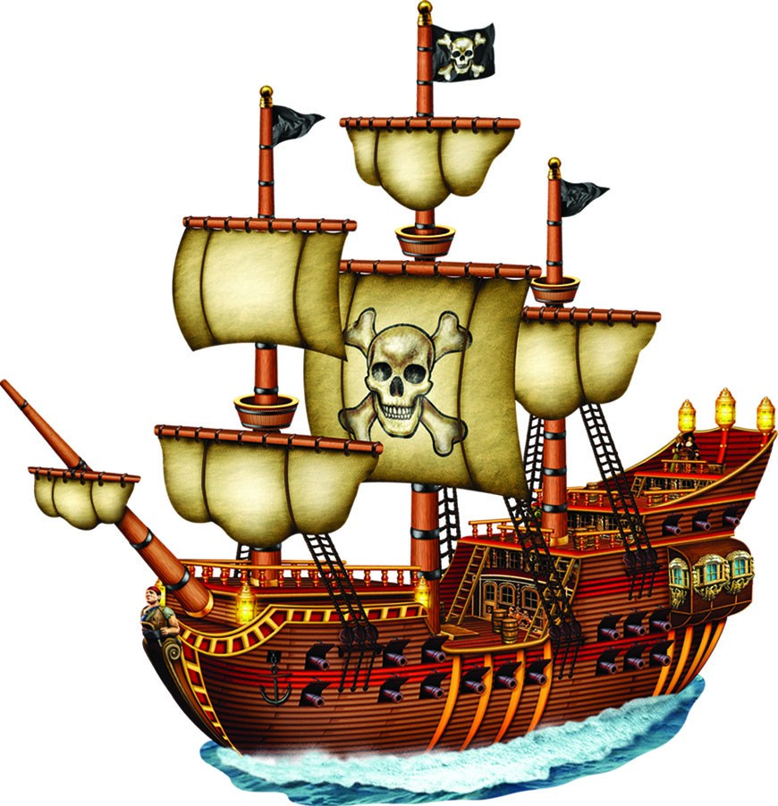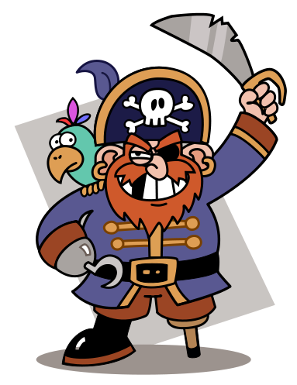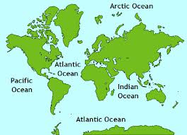

**Year 1**

**Set Sail**

**Term 2a**

**Sr**

**RE (Understanding Christianity)**

**Creation** - Who made the world?

**Maths** problem solving will have cross-curricular and topic links including global learning links

**Measurement: Length and Height** – Comparing lengths and height. Measuring lengths (in non-standard units). Introducing measuring with a ruler. Problem solving involving length.

**Number: Adittion and Subtraction within 20** – Adding by counting on. Number bonds for 20. Add by making 10. Subtraction by counting back. Comparing number sentences.

Maths meeting – Counting forwards and backwards to 100, counting in 2’s, 5’s and 10’s, adding 10 to a single digit number and number bonds for 10.

**Science**

**Everyday materials:**

To ask and answer questions. For example, Which is the best material for making a mop?

Using their observations to suggest answers to questions.

To carry out simple experiments.

**Enhanced provision**

**Enquiry Area** – Science

**Role play** – Pirate ship

**Reading corner** – Pirate stories

**Creative/DT** – Make pirates, parrots and ships

**Maths**– Maths linked to previous learning each week.

**Reading Area** – Linked to ing/ed words, prefix un, real and alien words and compound words

**Large tuff tray** – small word pirates, floating and sinking, building a plank for a pirate.

**Computing**

Unit 1.6 Animated story book using 2CreateAStory

To introduce e-books and 2Create a Story. To continue a previously saved story. To add animation to a story. To add sound to a story, including voice recording and music the children have created. To use additional features to enhance their stories. To share their e-books on a class display board.

**PSHE**

**Keeping/Staying Healthy:** Washing Hands

**Computer Safety:** Online Bullying

**Art**

**DIGITAL MEDIA** - take photos of themselves for portraits and add in own effects using Colourscape

**DRAWING** – portraits of themselves

**PAINTING AND PRINTING** - portraits of themselves

**ARTIST STUDY** - Andy Warhol and Picasso (portraits by artists)

**English**

* Phonics – Read Write Inc.
* Stories from fantasy worlds – The Story of Pirate Tom.
* Non Fiction – Pirates.

**PE**

Dance

**Enquiry**: We will enquire about different places around the world and we will use our investigative skills to enquire about the weather in Tankersley.

**Aiming high and self-belief** – we will set ourselves realistic targets and celebrate our achievements.

**Respect** – as respectful citizens we will learn to help one another and help to prevent accidents.

**Geography**

**How do we read and create simple maps?**

What are the features of the local area? What is the route to church? What are the countries and capital cities in the UK? What are the seas around the United Kingdom? Where is the Caribbean and what is it like? How is the Caribbean different to Tankersley? What would a treasure map look like?