Daily Learning Overview Grid for Parents
YEAR 2
Please remember your daily reading and spelling practice.
DAY: Friday 16th October
If you don’t have a printer, then please read the text from a screen and answer the questions on paper.
Reading/Writing lesson
For our English lesson today use the Oaks National Academy. The lesson is based around the story of Anansi and Tiger.
Please complete lesson 4: To use the conjunction ‘and’ to join clauses.
Paste the link below into your URL browser.
https://classroom.thenational.academy/lessons/to-use-the-conjunction-and-to-join-clauses-chjk6t
Phonics – Watch our daily Speed Sound video with Mrs Pitwell. Today’s focus sound is ‘oy’.
SPAG lesson
Practice this week’s spellings – see the spelling grid on the back of the homework folder.
Alternatively, you can read through the attached PowerPoint – Commas in a list.
Then answer the fluency and reasoning questions below.

Maths lesson
Read through the attached PowerPoint – Bonds to 100 (tens and ones)
Then complete the sheets below – Bonds to 100 (tens and ones)
Complete a 5-minute session on TTRockstars. Use your password that is on the front of your homework folder.
Alternatively log on to Purple Mash (using your password on the front of your homework folder) complete the 2Do Addition and Subtraction.
Creative curriculum lesson – RE / PHSE
Today we’re going to look at the story of Jesus calming the storm. Watch the video in the link below:

https://www.youtube.com/watch?v=uYLHqdSO9OY

Sometimes in life we may feel like we’re in the middle of a storm. Maybe we’re feeling sad or worried or maybe we’re going through a difficult time. It’s important to remember that Jesus is always with us, just like he was with his disciples on the boat. And in the same way that Jesus calmed the storm, he can help us too if we ask him.

Draw a picture of you in a terrible storm and draw Jesus next to you. Have a think about what the storm might represent in your life. Then write a prayer to Jesus to ask him to help you when you are feeling sad or worried or going through a difficult time.

PE activity
Paste this link into your computer and have some active fun learning about money.
https://www.bbc.co.uk/teach/supermovers/ks1-maths-money/zht4nrd
ICT Lesson
Log on to Purplemash and click on the 2Dos tab. In the 2Dos tab you will find Chimp act 1 Purple Disco. Launch the app and follow the instructions. If you get stuck you can always click on the hint, to give you clues.

Here are the website links you may need for the day’s learning
https://ttrockstars.com/

https://login.mymaths.co.uk/login

https://whiterosemaths.com/homelearning/
https://www.purplemash.com/login/
Please contact the class teacher on the year group virtual email if anything on the daily learning grid is not clear – the virtual email is in the home learning part of the website.

Friday SPAG
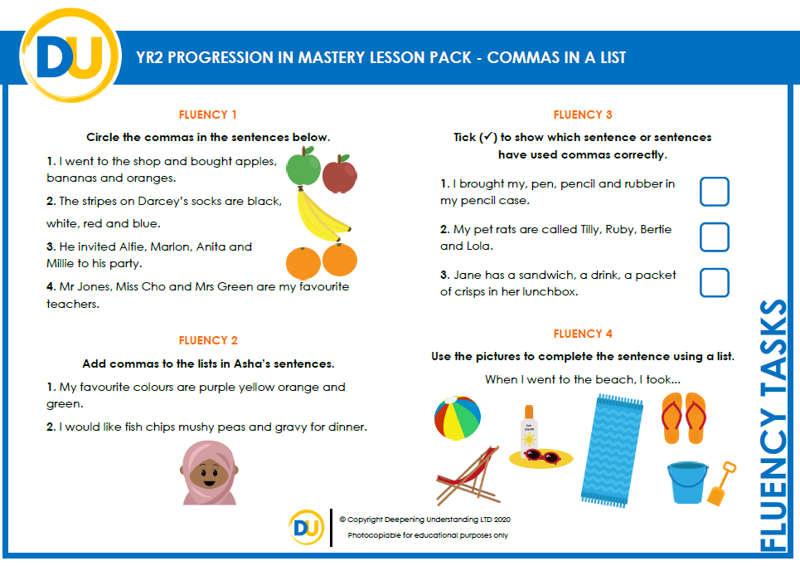
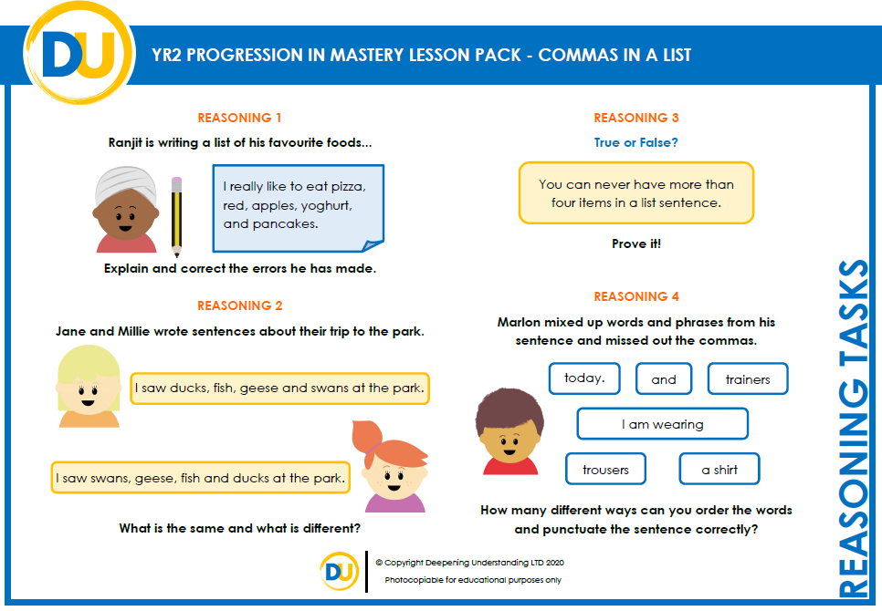Friday Maths
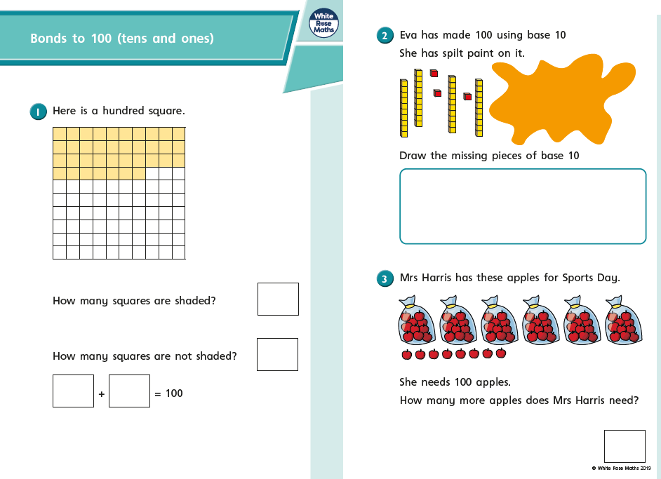

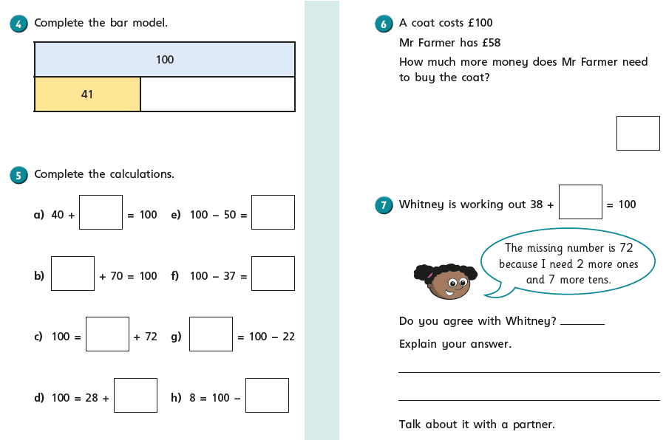
Friday – RE / PSHE

Watch the video of Jesus calming the storm using the link in the grid above. Follow the instructions to complete the picture and prayer below:
Jesus and me in the storm.

My prayer to Jesus:
________________________________________________________
________________________________________________________
________________________________________________________
________________________________________________________

