We have two exciting events in Class 4 this week!
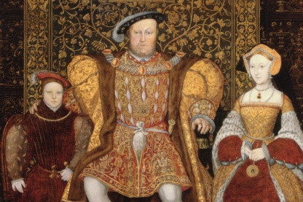
Firstly, on Tuesday 21st November we are performing our Class Assembly about the Tudors. All parents and carers of Class 4 are invited. It will start at 2.45pm in the school hall.

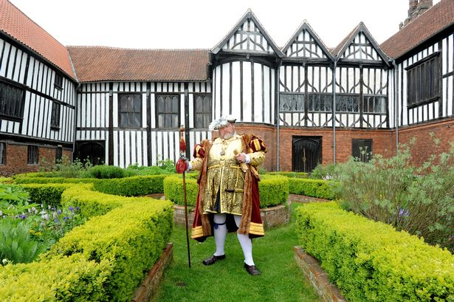
Secondly, it is our trip to Gainsborough Old Hall on Wednesday 22nd November. Just a few reminders. Firstly, there is no heating in the Old Hall itself and it is frequently colder than outside, so all children need a warm coat, gloves might also be useful. Children need to wear school uniform. Unless you have ordered a school packed lunch, the children will need a packed lunch and a drink. They can also bring some spending money, up to £4.00. Most importantly, we will be registering the children early on Wednesday morning, so they need to be in school by 8.15am so we can leave promptly at 8.30am. We will be back by 3.30pm.

Also this week:

English: We will be writing a recount about our trip.

Maths: Continuing our work on finding and measuring perimeters and solving problems involving perimeter.

We also welcome two teacher trainees into Class 4 this week. Holly Smith and Rachel Lowry will be joining us from Sheffield Hallam University for this week and then one day a week for the next few months, leading up to being in class full time later next term, before they finish at Easter.

Many thanks,
Mrs Maskill and Mrs Cocker

